**VALUER REPORT UID NO.:CEV/RVO/299/4183/21022025 21.02.2025**

**The Asst. General Manager**

**UCO Bank, Sector-17B, Chandigarh**

**VALUATION REPORT ( IN RESPECT OF Flat)**

|  |  |  |  |  |  |  |  |
| --- | --- | --- | --- | --- | --- | --- | --- |
| **I** | General | |  | |  | | |
| 1. | Date and Time of Inspection | |  | | 21.02.2025at 01.00 PM | | |
| 2. | Purpose for which valuation is made | |  | | Bank’s Purpose | | |
| 3. | Name of the Bank for which valuation is made | |  | | **UCO Bank** | | |
|  | Address of the property to be valued | |  | | **Flat No. 212, 5th floor ,Block B-9,Gulmohar City,Derabassi,Distt. Mohali,Pb.** | | |
| 4. | Owner’s &Borrowers’ Name and Address | | : | | **Owner/seller :Mukesh Kapoor s/o Vijay Kapoor**  **Buyer’s name :Jyoti Jhaw/o Ranjeet Jha and Ranjeet Jha s/o Yogi Jha** | | |
| 5 | List of the documents handed over to the Valuer by the branch | | : | | **1.agreement To sell:** dt. 29.01.2025 between seller/Owner :Mukesh Kapoor s/o Vijay Kapoor and buyers Jyoti Jhaw/o Ranjeet Jha and Ranjeet Jha s/o Yogi Jha  **2.Possession:** dt 23.02.2013 by Mukesh Kapoor  **3.NOC:** by the Builder Company in faour of Jyoti Jha & Ranjeet Jha on dated 28.01.2025 | | |
| 6 | Details of the enquiries made/visited to the Govt. offices | | : | | Inquiries made from local property dealers and searches made from real property web sites like **“Makaan.com,magicbricks.com&99acres.com**”and screen shots of the same taken and appended with the valuation report for ready reference of the bank. | | |
| **II.**  **Property Details**  - | | | | | | | |
| 1. | If the property is under the joint ownership/co-ownership share of the such owner/undivided | |  | | **Singleownership(100% Share)** | | |
| 2. | Brief description of the property (whether open land, House property, land area, built up area, no. of floor etc.) | |  | | **Flat No. 212,5th floor,Block B-9,Gulmohar City,Derabassi,Distt. Mohali,Pb.** | | |
| 3. | Dimensions of site  **Lats. 30.777475&Long. 76.8051560** | |  | | As per deed | | Actual at site |
| **Covered area 1112 sft** | | **Covered area 1112 sft** |
| 4. | Postal Address of the property | |  | | **Flat No. 212,5th floor,Block B-9,Gulmohar City,Derabassi,Distt. Mohali,Pb.** | | |
| 5. | Boundaries of the property | |  | | North- Flat No. 211  South - Open Area  East - Open Area  West - Flat No. 209 | | |
| 6. | Any specific identification marks (Like a famous buildings, famous house, some landmark area etc.) | |  | | Property is easily accessible through property number allotted | | |
| 7. | Route map enclosed | |  | | No need as the Google location is attached with the report | | |
| 8. | Whether covered under corporation/Panchayat/Municipality. | |  | | MC Derabassi | | |
| 9. | Whether covered under any land ceiling of state/central government. | |  | | NA | | |
| 10. | Is the land freehold/leasehold | |  | | Freehold | | |
| 11. | Are there any restriction covenants in regard to use of land | |  | | For Residential purpose only | | |
| 12. | Type of the property  Agricultural  Industrial  Commercial  Institutional  Government  Non-Government  Other ( Specify) | |  | | -  -  -  -  -  -  Residential | | |
| 13. | In case of agricultural land | |  | | NA | | |
| 14. | Year of Acquisition/purchase | |  | | 2013 | | |
| 15. | Value of purchase price | |  | | Rs.24.50 lac | | |
| 16. | Whether owner/tenant occupies the property? If occupied by the tenant? Since how long he is staying and the amount of | |  | | owner | | |
| 17. | Classification of the site  -Population group(metro/urban/semi- urban/rural)  -Class( High/Middle/Poor)  -Residential/Non-residential  Development of surrounding areas  -Possibility of any threat of the property(floods, calamities etc) | |  | | Semi Urban  Middle  Residential  Developed  No | | |
| 18. | Proximity of civic amenities like school, hospital, bus-stop, market etc) | |  | | All amenities available at a distance of 1km to 5 km | | |
| 19. | Level of land ( plain/rock etc.) | |  | | Plain | | |
| 20. | Terrain of land | |  | | Plain | | |
| 21. | Shape of land(Square/Rectangular etc.) | |  | | Rectangular | | |
| 22**.** | Type of use to which it can be put. | |  | | Residential | | |
| 23. | Any usage restriction | | |  | For Residential purpose only | | |
| 24. | Whether the plot is under town planning | | |  | Yes | | |
| 25. | Whether the plot is Intermittent or corner | | |  | Intermittent Flat | | |
| 26. | Whether any road facility is available? | | |  | Yes | | |
| 27. | Type of road available(B.T./ cement road) | | |  | B.T.Road | | |
| 28. | Front width of the road | | |  | More than 20ft. | | |
| 29. | Source of water | | |  | yes | | |
| 30. | Type of sewerage system | | |  | Under ground | | |
| 31 | Availability of water supply | | |  | Yes | | |
| 32. | Advantages of site | | |  | - | | |
| 33. | Disadvantages of site | | |  | - | | |
| 34. | Sale instances of the property in the locality | | |  | Not available | | |
| 35. | General remarks | | |  | - | | |
|  | **Mandate for Valuer** | | | | | | |
|  | **Nature of Security** | | | | |  | |
| a.) | Vacant Land (Agricultural/non-agricultural) | | | | | Non-agricultural | |
| b.) | Land with building thereon | | | | | Building constructed there-on | |
|  | Area of the land /Extant of land to be considered for valuation | | | | | Covered area 1112 sft | |
|  | In case of building, built up area. | | | | | Covered area 1112 sft | |
|  | In case of building under construction, status/progress of construction and approximate time required for completion | | | | | NA | |
|  | Distance of the site from the branch at Chandigarh | | | | | about25 km | |
|  | Location( with boundary) | | | | | **Flat No. 212,5th floor,Block B-9,Gulmohar City,Derabassi,Distt. Mohali,Pb.** | |
|  | Fair description and proper location of the assets, which are the subject of valuation, giving clearly identification, comments with reference to legal rights and restriction in ownership, if any | | | | | The property is easily identifiable from property number and for legal authenticity of documents ,legal rights and restriction in ownership of property,counsel of the bank may be consulted. | |
|  | | | | | | | |
|  | Plot No./Dag No. |  | | | | **Flat No. 212,5th floor,Block B-9,Gulmohar City,Derabassi,Distt. Mohali,Pb.** | |
|  | Khatauni no. |  | |  | | - | |
|  | P.S. |  | | | | - | |
|  | | | | | | | |
|  | Name of the present owner of the property | | | | | Owner :Mukesh Kapoor s/o Vijay Kapoor | |
|  | Present address of the owner | | | | | H.No. 106,Jagat Colony, Bhiwani,Hr. | |
|  | Occupation of the owner( if other than the applicant) | | | | | NA | |
|  | Relationship with the applicant | | | | | No | |
|  | No. of stories and age of the building | | | | | 5th floor | |
|  | Whether the property has been purchased by the present owner or inherited or received as a gift.(The Valuer should verify seller’s photo-ID and address) | | | | | Purchased by the present owner/seller | |
|  | Consideration/reason for offering the property as mortgage(in case of third party property) in case of third party collateral security.  (The valuer should obtain certified copy of the same documents and compare it with the originals submitted to the bank. He should collect the receipt from the “Amin” with date and seal .The valuer should verify documents like Patta, title deed and legal heir certificates from the issuing authorities. The valuer should also verify the latest property tax receipt , electricity bills etc.) | | | | | **Bank’s Purpose** | |
|  | Whether the property is free from tenancy? The valuer should make inquires with people residing in the property .He should also note the nature of tenancy (Commercial or Residential) and period of occupation. He should apply suitable reduction in the value. | | | | | NA | |
|  | Who is occupying the property at present | | | | | With owner | |
|  | Condition of the land/land & building from the point view of sale. | | | | | Normal | |
|  | Whether local enquiry made to satisfy about history of the property. | | | | | Yes | |
|  | The valuer in his report should mention the name/s of the persons present at the time of inspection or the person identifying the property. | | | | | Mukesh Kapoor ,the owner/seller | |
|  | Comments on the locality  (Posh/Middle class/ Lower middle class) | | | | | Middle Class | |
|  | Surroundings | | | | | Residential Area | |
|  | Connection of the locality with main city | | | | | Well connected | |
|  | Type of construction of the building(With posh amenities like marble flooring and costly fittings/ordinary fittings and equipments) | | | | | Detailed below | |
|  | Any discouraging report about property | | | | | No | |

**VALUATION OF THE PROPERTY OFFERED AS COLLATERAL SECURITY:**

**PART-A : Value of Land**

**The value of land depends upon its size, location and its placements, so keeping in mind these facts and sale instances of such properties in the area ,the value is taken as under :**

|  |  |  |  |  |  |  |  |
| --- | --- | --- | --- | --- | --- | --- | --- |
|  | Dimensions of the plot | | |  | | Not mentioned in docs | |
|  | Total area of the plot | | |  | | Undivided Share of Landnot mentioned, however covered area of flat=1112sft | |
|  | Prevailing market rates of flat | | |  | | Rs. 2500/- to 2700/-per Sft | |
|  | Guideline rates from the registrar office | | |  | | **Rs.2500/- per Sft** | |
|  | Assessed/Adopted rate of valuation | | |  | | Rs. 2550/-per Sft | |
|  | Estimated value of Flat | | |  | | 1112 x 2550= Rs. 28,35,600 /-**Say Rs. 28.30 Lac** | |
| **PART-B :Value of building**   1. **Technical details of the building:** | | | |  | | | |
|
|  | | Type of building  (Residential/Commercial/Industrial) |  | | Residential | |
|  | | Year of construction |  | | 2013,age 11yr. | |
|  | | **Future life of the building** |  | | **64years** | |
|  | | No. of floors and height of each floor including Basement |  | | Stilt+6 no. | |
|  | | Plinth area of each floor |  | | Covered Area = 1112 Sft As per Sale Agreement | |
|  | | Type of construction  (Load bearing/RCC/Steel Framed) |  | | RCC Framed | |
|  | | Condition of the building  External(Excellent/good/normal /poor)  Internal(Excellent/good/normal /poor) |  | | Photograph attached,  normal  normal | |

1. **Specifications of construction:**

|  |  |  |
| --- | --- | --- |
|  | **Description** | **Fifth Floor** |
|  | Foundation | RCC |
|  | Basement | No |
|  | Superstructure | Brick Masonry Walls in cement sand mortar |
|  | Joinery/door and windows | Hard wood used in joinery work |
|  | RCC works | RCC Slab&beamsetc. |
|  | Plastering | Cement sand plaster |
|  | Flooring / skirting | Vitrified Tiles Flooring |
|  | Any special finishing | NA |
|  | Whether any water proof course is provided? | Yes |
|  | Drainage | By Concealed pipes |
|  | Compound wall (types of const.) | NA |
|  | Electrical installation ( type of wire, class or fittings) | Concealed conduit |
|  | Plumbing installation | Ordinary |
|  | Bore well | yes |
|  | Wardrobes, if any | Yes |
|  | Development of open areas in the house. | - |

**Details of valuation:**

|  |  |  |  |  |  |  |  |
| --- | --- | --- | --- | --- | --- | --- | --- |
|  | **Floors/**  **Level** | **Particulars/Description of the items** | **covered**  **area ( in Sq.ft.)** | **Estimated replacement Rate per Sq.ft. (in Rs.)** | **Estimated replacement cost** | **Depreciation** | **Net value** |
| **1** | Flat at FifthFloor | NA | 1112 | 2550 | Rs. 28,35,600 /- | **Dep. Included In the Rate** | **Say Rs. 28.30 lac (composite Rate of Land & Building considered)** |

**PART- C (Extra Items) : (Amount in Rs.)**

|  |  |  |  |
| --- | --- | --- | --- |
| 1. | Protico) | : | NIL |
| 2. | Ornamental front door) | : | NIL |
| 3. | Sitout/Verandah with steel grills | : | NIL |
| 4 | Overhead water tank | : | NIL |
| 5. | Extra steel/ collapsible gates | : | NIL |

**PART- D (Amenities) : (Amount in Rs.)**

1. Wardrobes :Nil
2. Glazed Tiles :NIL
3. Extra sink and bath tub :NIL
4. Marble/Ceramic tiles flooring :NIL
5. Interior decorations :NIL
6. Architectural evolution works :NIL
7. Paneling works :NIL
8. Aluminum works :NIL
9. Aluminum Hand rails :NIL
10. False ceiling**:**NIL

**Total :Nil**

**PART- E ( Services) :(Amount in Rs.)**

1. Water supply arrangements :NIL
2. Drainage arrangements :NIL
3. Compound walls :NIL
4. C. B. deposits, fittings etc. :NIL
5. Pavement :NIL

**Total : ( NIL)**

**TOTAL ABSTARCT OF THE ENTIRE PROPERTY**

|  |  |  |  |  |
| --- | --- | --- | --- | --- |
|  | Part-A | Land | **:** | Rs. 28.30 lac(Composite Rate of Land & Building) |
|  | Part-B | Buildings | **:** |
|  | Part-C | Extra Items | **:** | NIL |
|  | Part-D | Amenities | **:** | Nil |
|  | Part-E | Services | **:** | NIL |
| **Total** | | |  | **28.30 Lac** |

**Note:**The Valuation has been made adopting market approach for the cost of Flat from similar properties situated in the same locality or in vicinity searched from web site of **“Makaan.com, magicbricks.com,99acres.com**Average rate of 3 similar / comparable available property considered as also verified personally from local real estate dealers & neighbors**.** There is gap in book value of the property as per Collector rates and fair market value prevailing as on date of the above property. Sale instances of prevailing market rates cannot be made available as people are always interested in saving the stamp duty and hence get the property registered at the Collector rates only which are much less than the market value .

This report doesn’t cover legal aspects, ownership aspects. Report is based on the documents & information as furnished by the bank. The verification of authenticity, genuineness of documents viz-a-viz matching the documents &records with those at site, location of property, encumbrances,ownershiprights,lawful freehold fragmentation of house ,its land use ,Mortgage/Acquisition notices, if any,etc. etc. doesn’t fall under my purview/jurisdiction. The bank should confirm these aspects / seek legal opinion in these matters.

In case the valuation report submitted by the valuer is not in order, the Bank must bring the same to the notice of the valuer within 15 days of submission for rectification and resubmission. In case no such communication is sent, it shall be presumed that the valuation report has been accepted.

Also, such aspects as:

1. **Saleability**: Depends on demand varying from time to time
2. **Rental values** : Depends on demand varying from time to time

1. Photograph of owner/representative with property in background enclosed

2. Screen shot of longitude/latitude and co-ordinates of property using GPS/Various Apps/Internet sites.

As a result of my appraisal and analysis, it is my considered opinion that the various valuesof the above property in the prevailing condition with aforesaid specifications are:

**1.Present fair market value -Rs 28.30 lac( Rupees Twenty eight Lac thirty thousand only)**

**2**.**Net Realizable Value - Rs 24.47 lac(Rupees twenty four Lac forty seven thousand only) and**

**3.Distress value - Rs 21.20lac (Rupees Twnety one Lac Twnety Thousand only).**

Place: **Panchkula**

Date: **21.02.2025**

**Signature of Valuer**

The undersigned has inspected the property detailed in the Valuation Report dated­­­­­­­­­­­­­­­­­­­­­­­­­­­­________________on __________________.We are satisfied that the fair & reasonable market value of the property is Rs. ____________________(Rs._______________________________only)

Date: **Signature**

**(Name Of The Branch Manager With Office Seal)**

**Collector Rates of SubTehsil Majri, Distt. Mohali (Pb.) for the ye. 2024-25**

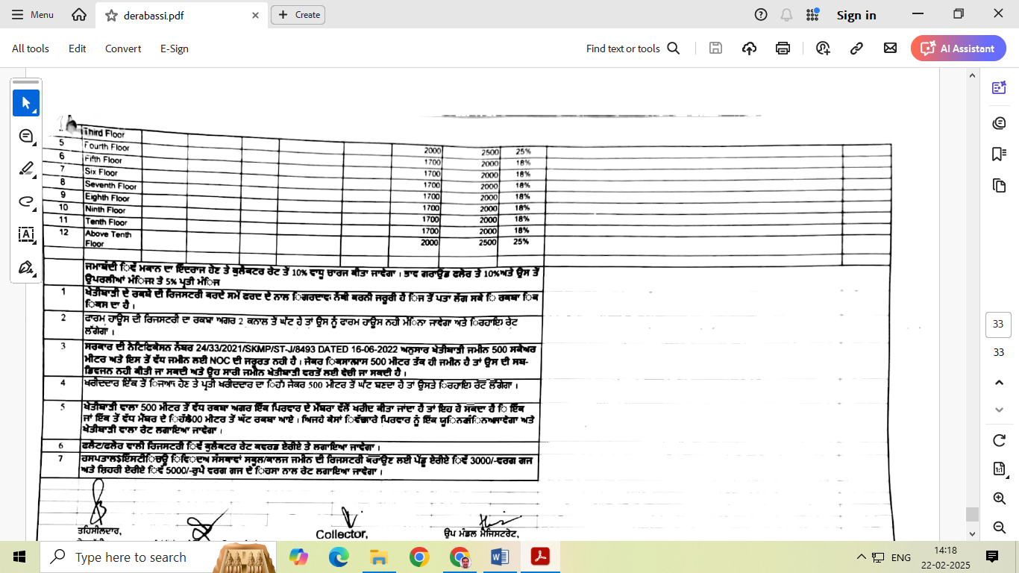

**Downloaded Docs**

**Signature of Valuer**

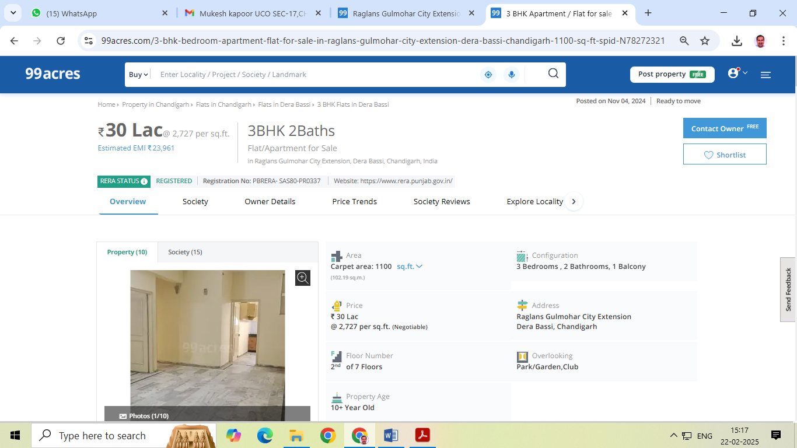

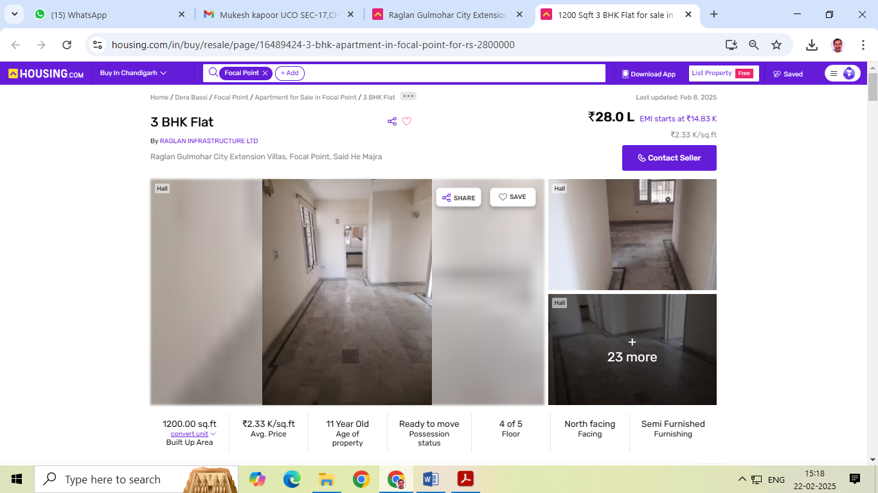

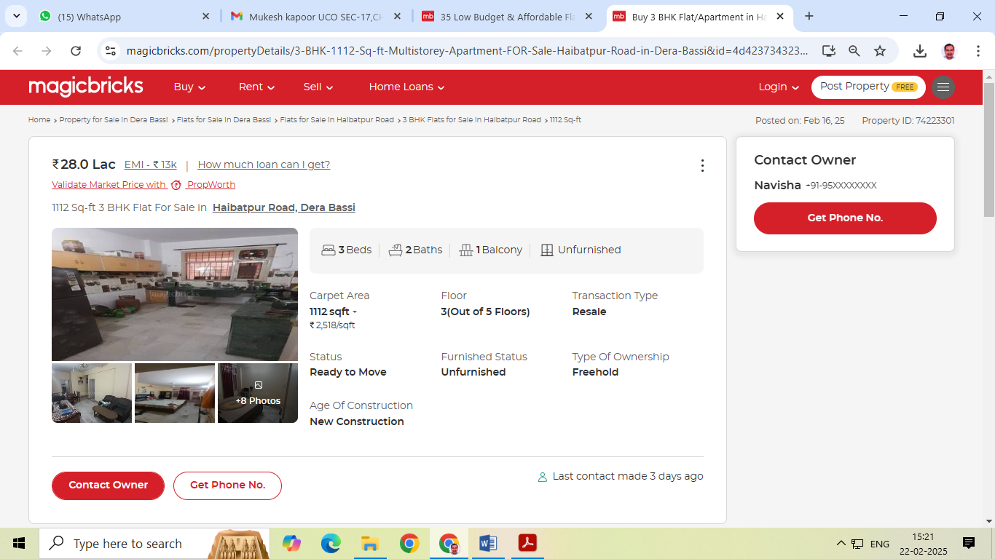

**Photos ofFlat No. 212,2nd floor ,Block B-9,Gulmohar City,Derabassi,Distt. Mohali,Pb.**

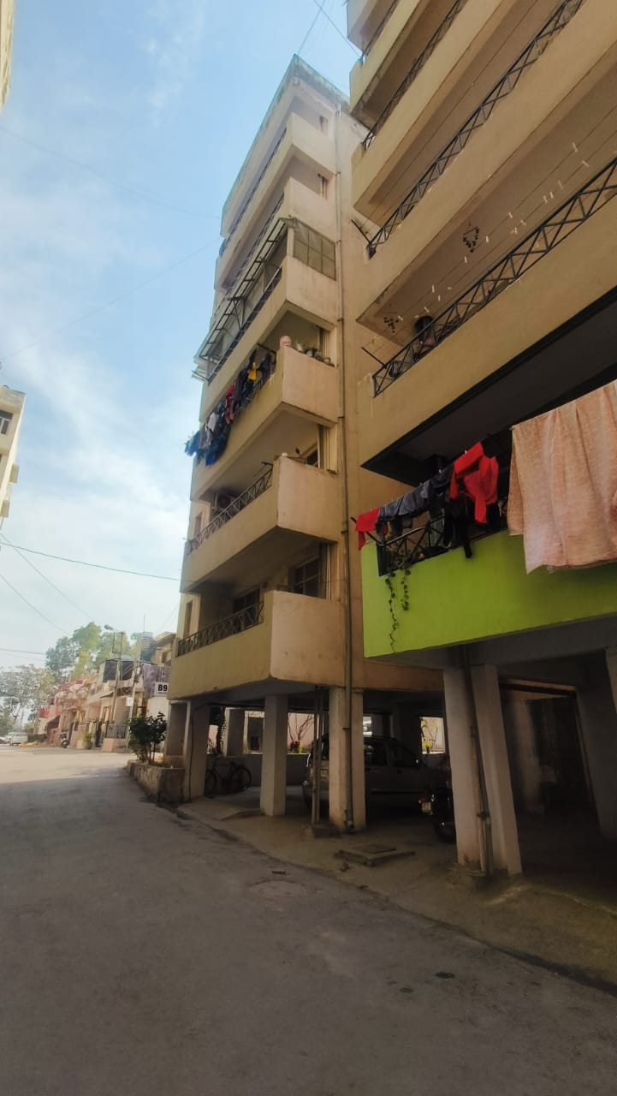 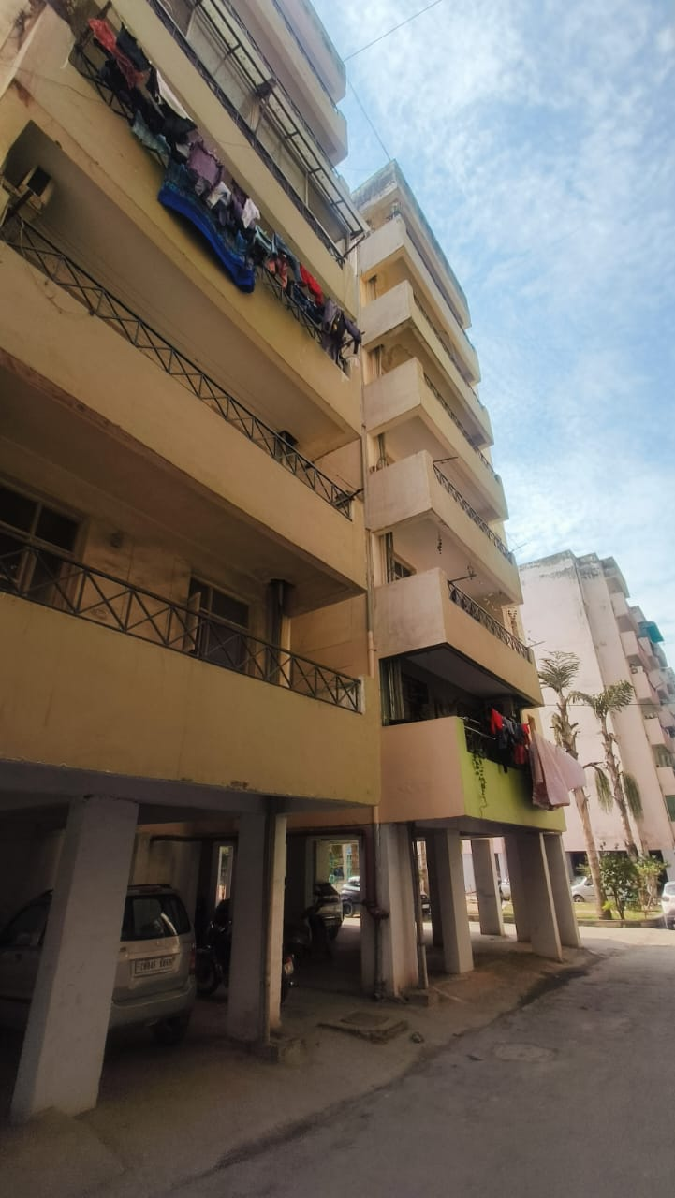

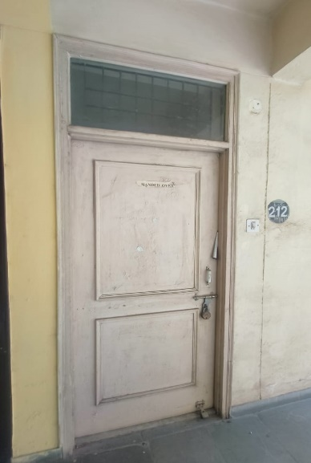 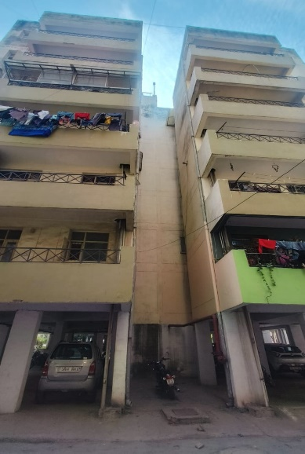

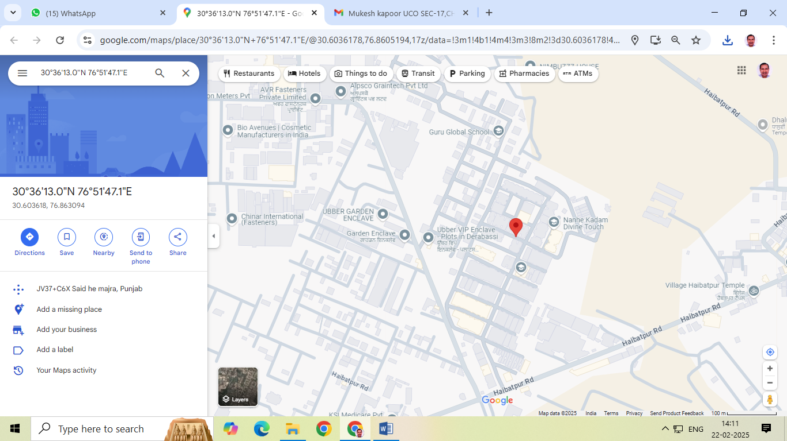

Late Sh. Chhelu Ram do hereby solemnly affirm and state that: a. I am a citizen of India b. I will not undertake valuation of any assets in which I have a direct or indirect interest or become so interested at any time during a period of three years prior to my appointment as valuer or three years after the valuation of assets was conducted by me c. The information furnished in my valuation report dated DD-MM-YYYY is true and correct to the best of my knowledge and belief and I have made an impartial and true valuation of the property. d. I have personally inspected the property on DD-MM-YYYY The work is not subcontracted to any other valuer and carried out by myself. e. Valuation report is submitted in the format as prescribed by the Bank f. I have not been depanelled/ delisted by any other bank and in case any such depanelment by other banks during my empanelment with you, I will inform you within 3 days of such depanelment. f. I have not been removed/dismissed from service/employment earlier g. I have not been convicted of any offence and sentenced to a term of imprisonment h. I have not been found guilty of misconduct in professional capacity L have not been declared to be unsound mind J. I am not an undischarged bankrupt, or has not applied to be adjudicated as a bankrupt; k. I am not an undischarged insolvent L. I have not been levied a penalty under section 2711 of Income-tax Act, 1961 (43 of 1961) and time limit for filing appeal before Commissioner of Incometax (Appeals) or income-tax Appellate Tribunal, as the case may be has expired, or such penalty has been confirmed by Income-tax Appellate Tribunal, and five years have not elapsed after levy of such penalty m. I have not been convicted of an offence connected with any proceeding under the Income Tax Act 1961, Wealth Tax Act 1957 or Gift Tax Act 1958 and n. My PAN Card number/Service Tax number as applicable is o. I undertake to keep you informed of any events or happenings which would make me ineligible for empanelment as a valuer

I have not concealed or suppressed any material information, facts and records and I have made a complete and full disclosure q. Thave read the Handbook on Policy, Standards and procedure for Real Estate Valuation, 2011 of the IBA and this report is in conformity to the "Standards" enshrined for valuation in the Part-B of the above handbook to the best of my ability r. I have read the International Valuation Standards (IVS) and the report submitted to the Bank for the respective asset class is in conformity to the "Standards" as enshrined for valuation in the IVS in "General Standards" and "Asset Standards" as applicable s. I abide by the Model Code of Conduct for empanelment of valuer in the Bank (Annexure V-A signed copy of same to be taken and kept along with this declaration) t. I am registered under Section 34 AB of the Wealth Tax Act, 1957. (Strike off, if not applicable) u. I am valuer registered with Insolvency & Bankruptcy Board of India (IBBI) (Strike off, if not applicable) v. My CIBIL Score and credit worthiness is as per Bank's guidelines, w. I am the proprietor/partner/authorized official of the firm/company, who is competent to sign this valuation report. x. I will undertake the valuation work on receipt of Letter of Engagement generated from the system (i.e. LLMS/LOS) only. y. Further, I hereby provide the following information.

|  |  |  |
| --- | --- | --- |
| Sl No. | Particulars | Valuer comment |
| 1 | background information of the asset being valued; | **Flat No. 212,5th floor,Block B-9,Gulmohar City,Derabassi,Distt. Mohali,Pb.** |
| 2 | purpose of valuation and appointing authority | Bank’s purpose |
| 3 | identity of the valuer and any other experts involved in the valuation; | Surinder Kumar Tindwal |
| 4 | disclosure of valuer interest or conflict, if any; | NO |
| 5 | date of appointment, valuation date and date of report: | 21.02.2025,21.02.2025 and 21.02.2025 |
| 6 | inspections and/or investigations undertaken; | Inspection on 21.02.2025 and meeting/ discussion/inquiry with property consultants of the area |
| 7 | nature and sources of the information used or relied upon; | Real estate web portals and property consultants of the area |
| 8 | procedures adopted in carrying out the valuation and valuation standards followed; | Market approach |
| 9 | restrictions on use of the report, if any; | NA |
| 10 | major factors that were taken into account during the valuation; | - |
| 11 | major factors that were not taken into account during the valuation; | - |
| 12 | Caveats, limitations and disclaimers to the extent they explain or elucidate the limitations faced by valuer, which shall not be for the purpose of limiting his responsibility for the valuation report. | **i**. I/We have not verified the title deeds of the properties with the records of registrar’s office as this is beyond the agreed scope of our services stated in our engagement letter.  ii. I/We assume no responsibility for the legal matters including, but not limited to, legal or title concerns. The assets and interests therein have been valued free and clear of any liens or encumbrances unless stated otherwise. No hidden or apparent conditions regarding the subject assets or their ownership are assumed to exist. No opinion of title is rendered by this report and a good title is assumed.  iii. The RV has endeavoured to visually identify the land boundaries and dimensions; however, he is not a surveyor. So where there is a doubt about the precise position of the structures, it is recommended that a Licensed Surveyor be contacted.  iv. The physical condition of the improvements was based on visual inspection. No liability is assumed for the soundness of the structure since no engineering tests were made at the site. Any unknown conditions existing at the time of inspection could alter the value. No responsibility is assumed for latent defects of any nature whatsoever, which may affect value, nor for any expertise required to disclose such conditions.  v. Where a sketched plan is attached to this report, it does not purport to represent accurate architectural plans. Sketch plans and photographs are provided as general illustrations only.  vi. Unless otherwise stated as part of the terms of engagement, the RV has not made a specific compliance survey or analysis of the various permits and licenses under central, state and local laws / regulations applicable to the operation and use of the subject property, and this valuation does not consider the effect, if any, of non-compliance.  vii. The sale of the subject property is assumed to be on an all cash basis. Financial arrangements would affect the price at which the property may sell for if placed on the market.  viii. Value varies with the purpose and date. This report is not to be referred if the purpose is different other than mentioned.  ix. The actual realizable value that is likely to be fetched upon sale of the property under consideration shall entirely depend on the demand and supply of the same in the market at the time of sale.  x. In the course of the valuation, we were provided with both written and verbal information. We have however, evaluated the information provided to us by the Company through broad inquiry, analysis and review but have not carried out a due diligence or audit of the information provided for the purpose of this engagement. Our conclusions are based on the assumptions, forecasts and other information given by/on behalf of the Company.  xi. We are independent of the client/company and have no current or expected interest in the Company or its assets. The fee paid for our services in no way influenced the results of our analysis.  xii. Our report is meant for the purpose mentioned above and should not be used for any purpose other than the purpose mentioned therein. The Report should not be copied or reproduced without obtaining our prior written approval for any purpose other than the purpose for which it is prepared. |

Date: 21.02.2025

Place: Panchkula

**Signature**

**(Name of the approved valuer and seal of the Firm/company)**

**(Annexure-B)**

**MODEL CODE OF CONDUCT FOR VALUERS**

All the empanelled Valuers are required to adhere to the code of conduct given as under:

Integrity and Fairness:

1. A Valuer shall, in the conduct of his/its business, follow high standards of integrity and faimess in all its dealings with his/its clients and other Valuers

2. A Valuer shall maintain integrity by being honest, straightforward, and forthright in all professional relationships.

3. A Valuer shall endeavour to ensure that he/it provides true and adequate information and shall not misrepresent any facts or situations.

4. A Valuer shall refrain from being involved in any action that would bring disrepute to the profession 5. A Valuer shall keep public interest foremost while delivering his services

5. A Valuer shall keep public interest foremost while delivering his services.

Professional Competence and Due Care:

6. A Valuer shall render at all times high standards of service, exercise due diligence, ensure proper care and exercise independentprofessional judgments

7. A Valuer shall carry out professional service in accordance with the relevant technical and professional standards that may be specified from time to time.

8. A Valuer shall continuously maintain professional knowledge and skills to provide competent professional service based on up to date developments in practice, prevailing regulations/guidelines and techniques.

9. In the preparation of a Valuation report, the Valuer shall not disclaim liability for his/its expertise or deny his/its/duty of care, except to the extent that the assumptions are based on statements of fact provided by the company or its auditors or consultants or informationavailable in public domain and not generated by the Valuer

10. A Valuer shall not carry out any instructions of the client insofar as they are incompatible with the requirements of integrity, objectivity and independence.

11. A Valuer shall clearly state to his client the services that he would be competent to provide and the services for which he would be relying on other Valuers or professionals or for which the client can have a separate arrangement with other Valuers.Independence and Disclosure of Interest:

12. A Valuer shall act with objectivity in hisfits professional dealings by ensuring that his/its decisions are made without the presence ofany bias, conflict of interest, coercion, or undue influence of any party, whether directly connected to the Valuation assignment or not.

13. A Valuer shall wherever necessary disclose to the clients, possible sources of conflicts of duties and interest providing unbiasedservices

14. A Valuer shall maintains complete independence in his/its professional relationships and shall conduct the Valuation independent ofexternal influences

15. A Valuer shall not deal in securities of any subject company after any time when he/it first becomes aware of the possibility of his/its association with the Valuation, and in accordance with Bank of India the Securities and Exchange Board of India (Prohibition of Insider Trading) Regulations, 2015 or till the time the Valuation report becomes public, whichever is earlier.

16. A Valuer shall not indulge in mandate snatching or offering 'convenience Valuations' in order to cater to a company or client's needs

17. As an independent Valuer, the Valuer shall not charge success fee (success may be defined as a compensation/ incentive paid to any third party for successful closure of transaction. In this case, approval of credit proposals).

18. In any faimess opinion or independent expert opinion submitted by a Valuer, if there has been a prior engagement in an unconnected transaction, the Valuer shall declare the association with the company during the last five years.

Confidentiality:

19. A Valuer shall not use or divulge to other clients or any other party any confidential information about the subject company, which has come to his/its knowledge without proper and specific authority or unless there is a legal or professional right or duty to disclose.

Information Management:

20. A Valuer shall ensure that he/it maintains written contemporaneous records for any decision taken, the reasons for taking the

decision, and the information and evidence in support of such decision. This shall be maintained so as to sufficiently enable a

reasonable person to take a view on the appropriateness of his/its decisions and actions.

22. A Valuer shall appear, co-operate and be available for inspections and investigations carried out by the authority, any person authorized by the authority, the registered Valuers organization with which he/it is registered or any other statutory regulatory body.

23. A Valuer shall provide all information and records as may be required by the authority, the Tribunal, Appellate Tribunal, the

registered Valuers organization with which he/it is registered, or any other statutory regulatory body.

24. A Valuer while respecting the confidentiality of information acquired during the course of performing professional services shall maintain proper working papers for a period of three years or such longer period as required in its contract for a specific Valuation, for production before a regulatory authority or for a peer review. In the event of a pending case before the Tribunal or Appellate Tribunal,the record shall be maintained till the disposal of the case.

Gifts and Hospitality:

25. A Valuer or his fits relative shall not accept gifts or hospitality which undermines or affects his independence as a Valuer

Explanation-For the purposes of this code the term 'relative' shall have the same meaning as defined in clause (77) of section 2 of the companies Act, 2013 (18 of 2013).

26. A Valuer shall not offer gifts or hospitality or a financial or any other advantage to a public servant or any other person with a view to obtain or retain work for himself/itself, or to obtain or retain an advantage in the conduct of profession for himself/itself.

Remuneration and Costs:

27. A Valuer shall provide services for remuneration which is charged in a transparent manner, is a reasonable reflection of the worknecessarily and properly undertaken, and is not inconsistent with the applicable rules. Bank of India.

28. A Valuer shall not accept any fees or charges other than those which are disclosed in a written contract with the person to whom he would be rendering service.

Occupation, employability and restrictions

29. A Valuer shall refrain from accepting too many assignments, if he/it is unlikely to be able to devote adequate time to each of his/its assignments.

30. A Valuer shall not conduct business which in the opinion of the authority or the registered Valuer organization discredits the profession.

**Signature**

**(Name of the approved valuer and seal of the Firm/company)**